**A CRM APPLICATION FOR SCHOOLS/COLLEGES**

**1. INTRODUCTION:**

**OVERVIEW:**

**A School CRM is a software application used to automate and handle communication with current students, employees, & alumni. All this work is done on a single system. Every connection with customers is tracked by the customer relationship management system in one phone. With the help of customer relationship management software, you can take feedback from the customers, department and the students. Each interaction with your customers is tracked by the customer relationship management system. As, at a time there is an increase in the volume of leads, at that time this software is beneficial. This leads to enhancing the work efficiency and visibility of a business.**

**PURPOSE:**

* **School and colleges can use CRM software to track students from the admissions process all the way of graduation.**
* **CRM can also help student achieve academic success and maintain personal well-being, if set up to remind students of upcoming deadlines, exam schedule, or information resources.**
* **It helps schools and colleges in managing students data and interactions, automate tasks related to recruitment and enrollment, and retention efforts. It can also help to increase the effectiveness of enrollment campaigns.**

**2. PROBLEM DEFINITION & DESIGN THINKING:**

**EMPATHY MAP:**

**Empathy mapping is tool that really helps you get to know your customers. By understanding what your customers think, feel, say and do you can develop rich insight which helps you so identify issues, problems or concerns that your customer may have right now.**

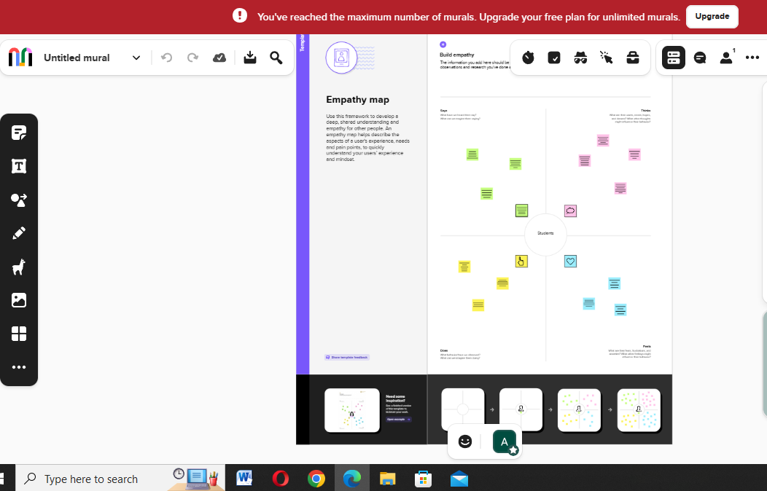

**IDEATION & BRAINSTORMING MAP:**

**Ideation is often closely related to the practice of brainstorming, a specific technique that is utilized to generate new ideas. A principal difference between ideation and brainstorming is that ideation is commonly more thought of as being an individual pursuit, while brainstorming is almost always a group activity.**

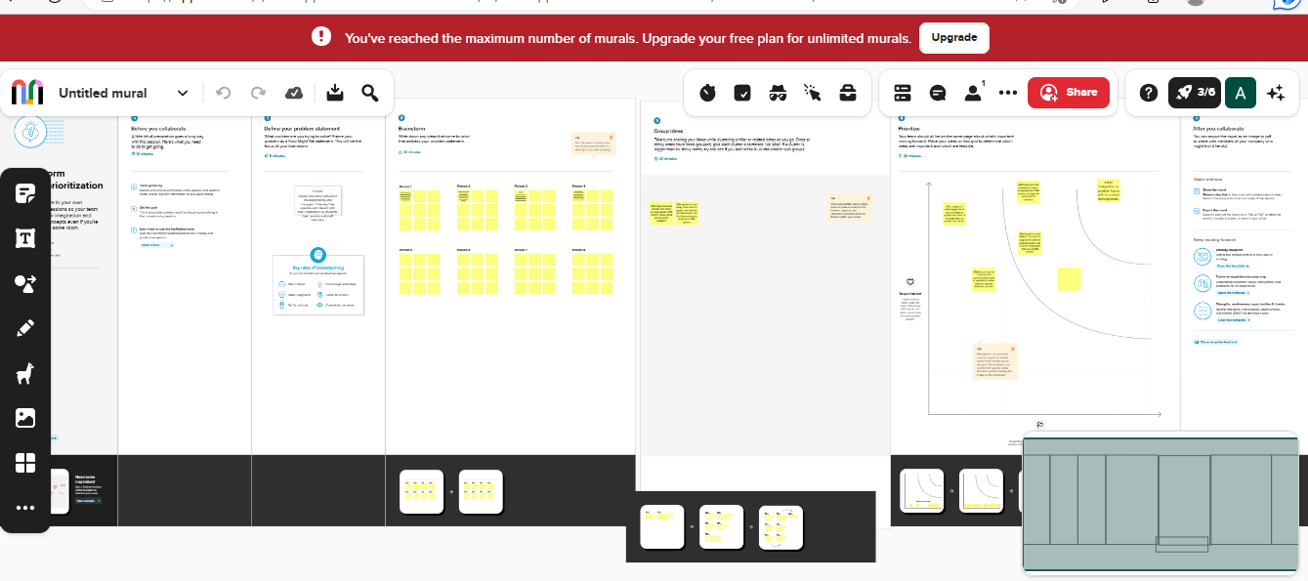

**3. REPORTS:**

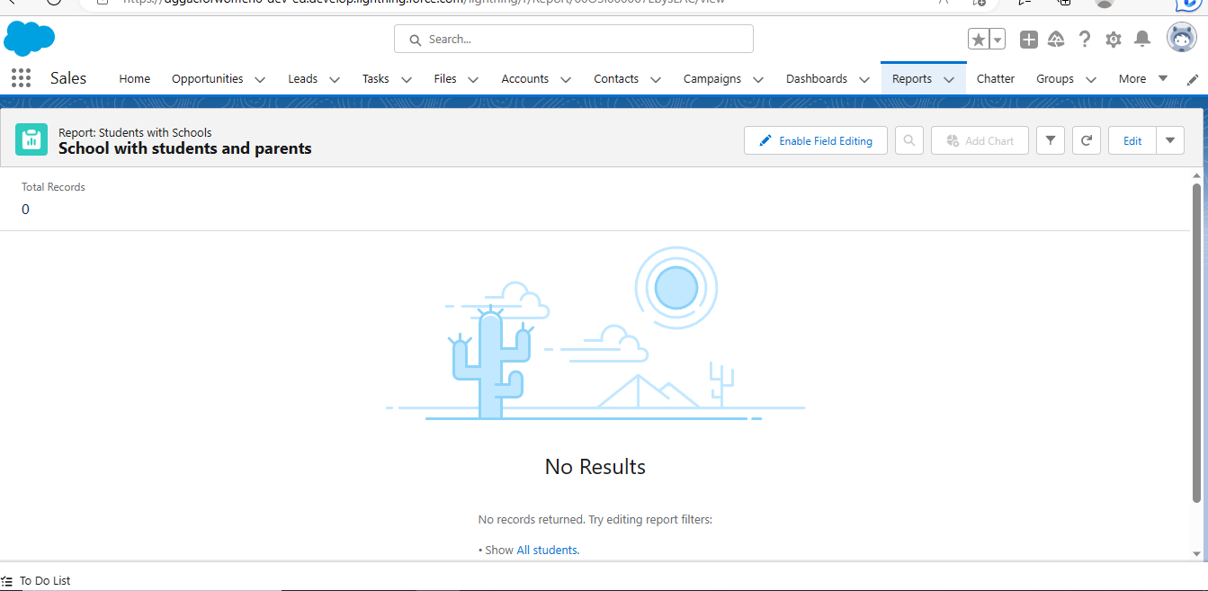

**4. ADVANTAGES & DISADVANTAGES:**

**ADVANTAGES:**

**1] Improve Student Admissions Life Cycle.**

**CEM for educational institutions track and automates the tasks involved in the admission process, such as gathering and storing applicant’s data, sending messages to inform about their enrollment status etc.**

**2] REDUCTION IN THE COST OF EXPENSES.**

**CRM automates and standardized online learning process it reduce cost by eliminating a lot of routine and manual steps.**

**3] KEEP THE ALUMNI INFORMATION SAFE AND ACCESSIBLE.**

**CRM save the data securely.**

**DISADVANTAGES:**

**1] One of the greatest challenges to CRM implementation is cost. There are dozens of software options available and many pricing plans that go with them.**

**2] Poor communication is also a disadvantage in CRM.**

**3] A lack of commitment or resistance to cultural change from people within the company can cause major difficulties with CRM implementation.**

**5] APPLICATION:**

**1] PERSONALISED COMMUNICATION.**

**A CRM system allows educational institutions to personalize communication with leads/prospect or students, resulting in more effective communication and better relationships.**

**2] INCREASED REVENUE.**

**By improving enrollment and student engagement, a CRM system can helps educational organization in increasing revenue.**

**3] LEAD MANAGEMENT.**

**Educational organizations to more effectively manage leads, including leads scoring segmentation and personalized follow-up.**

**4] IMPROVED STUDENT ENGAGEMENT.**

**CRMs helps in improving student engagement by tracking student interaction and providing personalized communication.**

**5] IMPROVED ENROLMENT.**

**A CRM system can help counselor or representative to more effectively manage and track leads, and resulting in increasing enrolment numbers.**

**6] FUTURE SCOPE:**

**CRM software for schools should enable the teaching authorities to choose the method and structure of the examination as per respective academic courses. This will ensure a better understanding of the curriculum to the learners.**

**The future of the CRM is bright. CRM will continue to report key data and give insight for future action, however, leading experts CRM evolving to measure and inform sales enablement and customer engagement.**

**7] CONCLUSION:**

**Customer relationship management enables a company to align it strategy with the needs of the customer in order to best meet those needs and thus ensure long-term customer loyalty.**